

### College of Science, Technology & Applied Arts of Trinidad & Tobago

### DEPARTMENT OF INFORMATION SCIENCE AND TECHNOLOGY

**GROUP ASSIGNMENT COVER PAGE**

**ASSIGNMENT TITLE:** Final Project

|  |  |  |
| --- | --- | --- |
| **ASSIGNMENT SUBTITLE:** |  |  |
| **COURSE CODE:** | ITEC 240 |
| **COURSE TITLE:** | Web Page Design |
| **CRN:** 10211 | **SEMESTER:** | 2024/25 |
| **STUDENT NAME** | **STUDENT I.D.** | **PROGRAMME** |
| **1.** Darlene Daniel | 00035429 | BLIS |
| 2. Leon Barratt | 00078071 |  |
| 3. Johnathan Wickham | 00079815 |  |
| **DATE OF SUBMISSION:** | 15th November 2024 |  |
| **LECTURER’S NAME:** | Ms. Nicole A. Alexander |  |

Webpage for the Ministry of Health

# Table Of Contents

**Table of Contents**

Table Of Contents 2

Level 1: Planning and Design 4

Storyboard 6

Level 2: Implementation 12

Appendix 1- W3C Validation 17

Appendix 2 19

Activity 20

Appendix 3- Citation 21

Organization Background

# Level 1: Planning and Design

* Purpose:

This webpage is an overview of what the Ministry of Health has done, showcase the emergency response services and contact info all for citizens to apply for medical aid. It also show cases the employees so that person can trust the employees. There is also ease of access to registration, sign in and login forms. There is also a map available it purpose is for staff and the general public to access with ease.

* Audience:

The audience for this webpage would be any citizen of Trinidad and Tobago over the age of 18.

* Structure:

In this web page we have decided to link all pages using the navigation bar so that if a user misclicks they don’t have to go back to the home page they can easily go to their desired page.

* Pages

This webpage will feature: a home page showcasing a brief description of the ministry, an about us page showcasing people who work in the ministry of health such as the Minister of Health and etc., a gallery showcasing images of things the ministry has done, successful surgeries and projects, a forms page showcasing the form citizens would need to fill out to request medical aid, a login page and a signup page and lastly a page with videos showing

basic first aid procedures and emergency response services contact info.

# Storyboard

## Home Page Wire Frame

## About Us Page

## Wire Frame

## Gallery Wire Frame

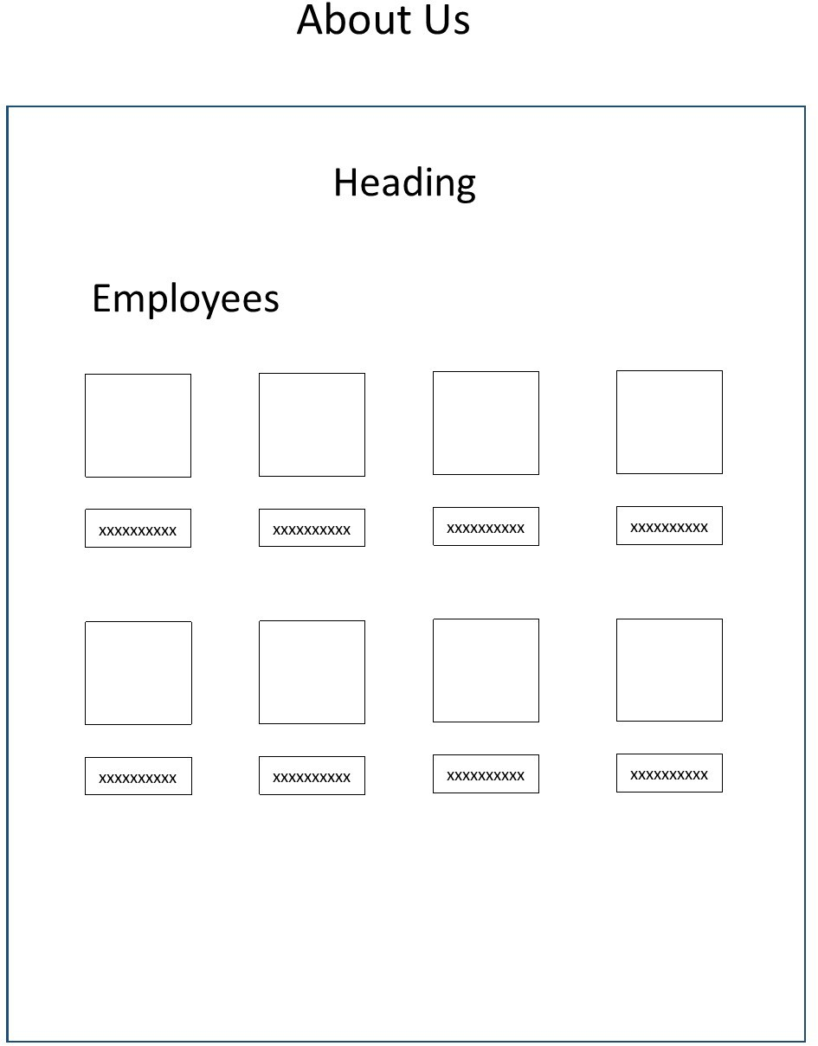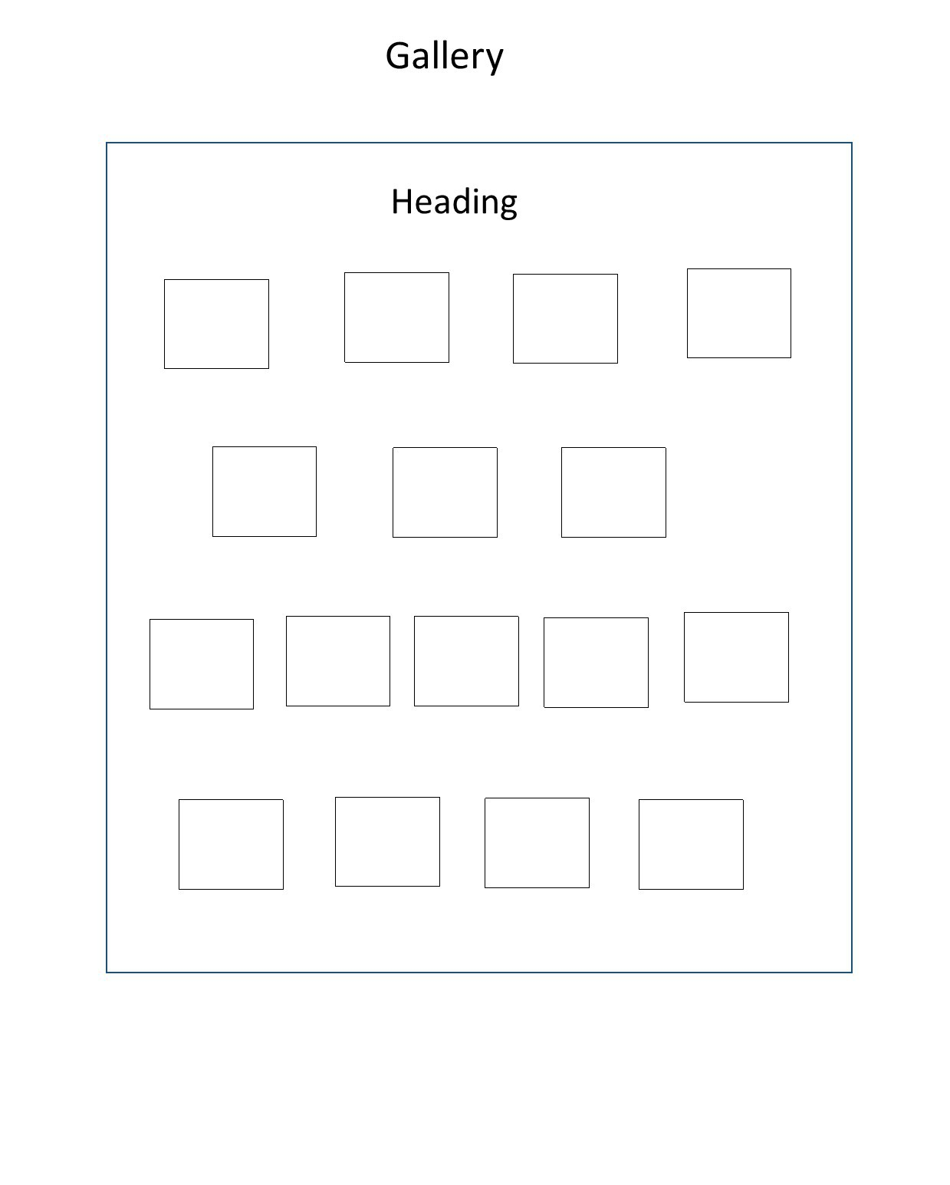

## Form Wire Frame

## Sign Up Page Wire Frame

## Login Wire Frame

## Support Page Wire Frame

## Full Webpage Layout

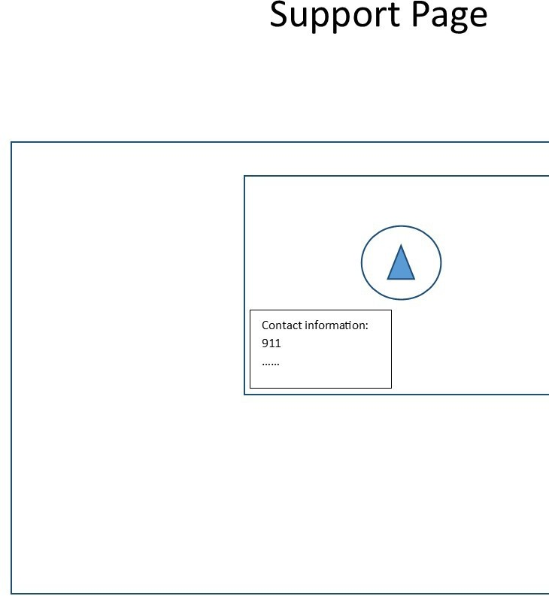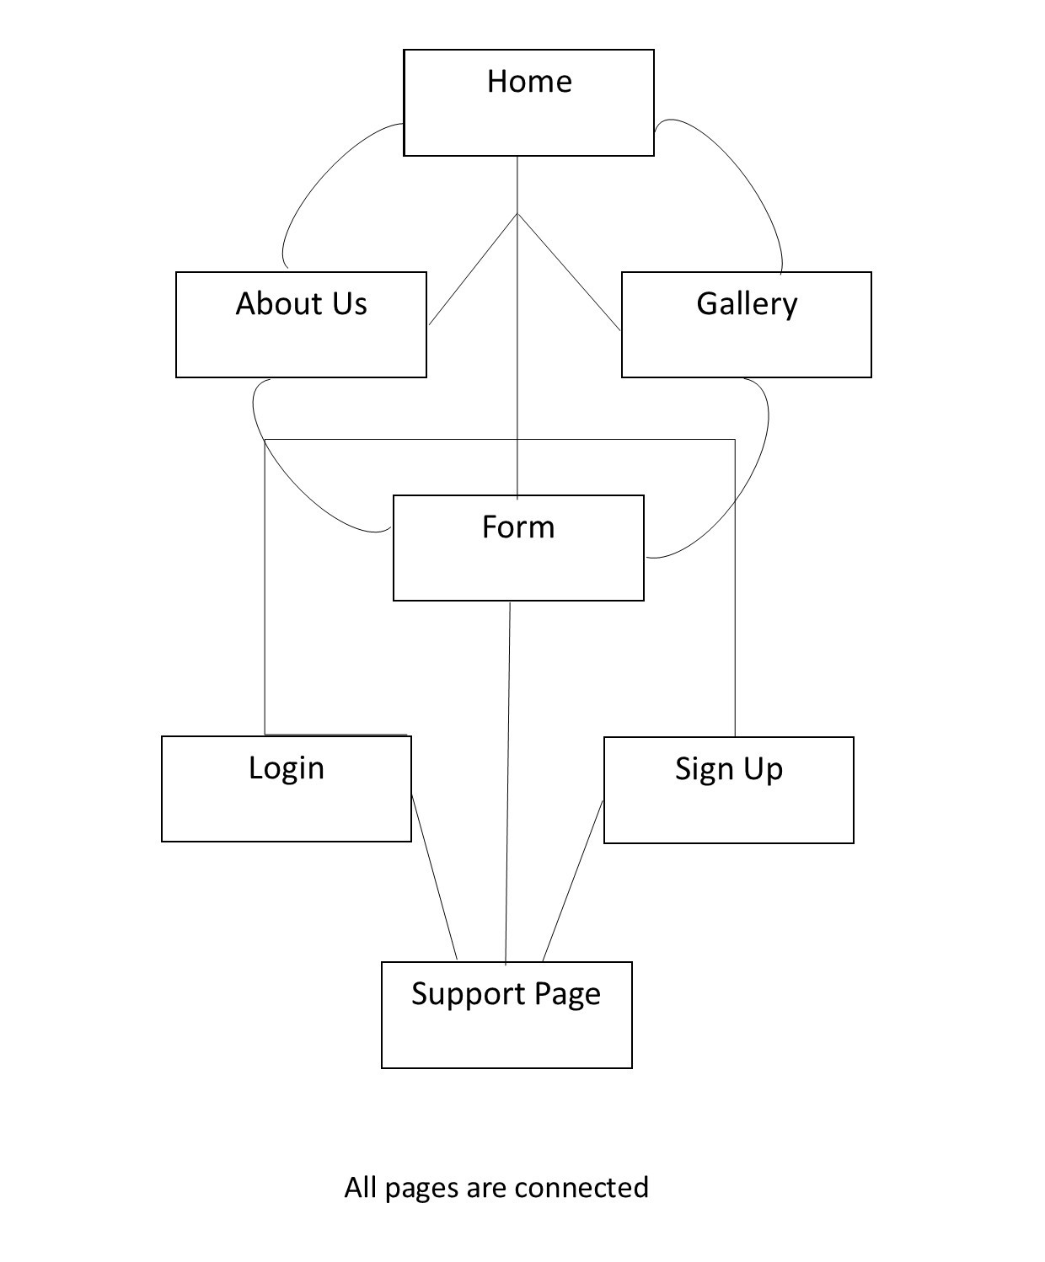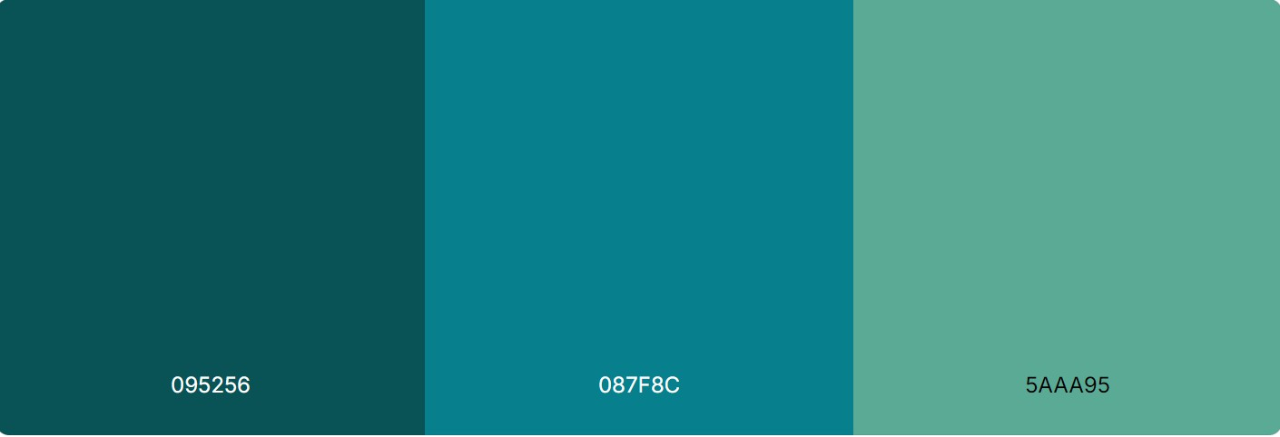

## Design

* Pa

lette

# Level 2: Implementation

## Screenshots/Description

Index/Home page

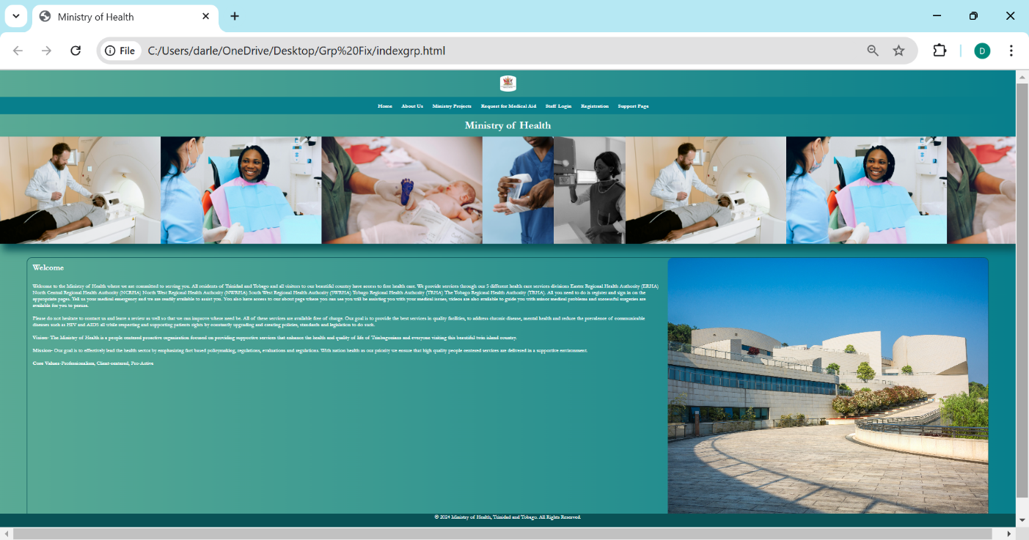Index Page Description

This the main page of the website and provides user quick access to all the other pages. It encompasses all the colours from the chosen palette. The navigation is set to change colour when hovered over. It has a logo in a set display block at the centre of the page. Images are used to give an idea of the purpose of the website also set to a block display with appropriate margins set at auto and padding at 20px. Appropriate classes were utilized for the header and navigation alike. The about us page is easily accessible from the navigation bar with its clickable link. Also a footer with the contact to the ministry with its background color #095256 and text aligned to the center and padding of 20px. Section, Classes were carefully added to make editing of the grid element easier. The slide motion is set within a container with its images having an object fit of cover that allows it to cover the whole span/ width of the page moving for 20 seconds in an absolute position that allows it to adjust to the page. Whereas the welcome paragraph is in its own grid element to allow for a paragraph to the right and image to the left with margins allowing it to be away from the direct corner of the page and the image is cut to fit within the grid in a cover position to avoid any distortion.

About Us Page Functionality

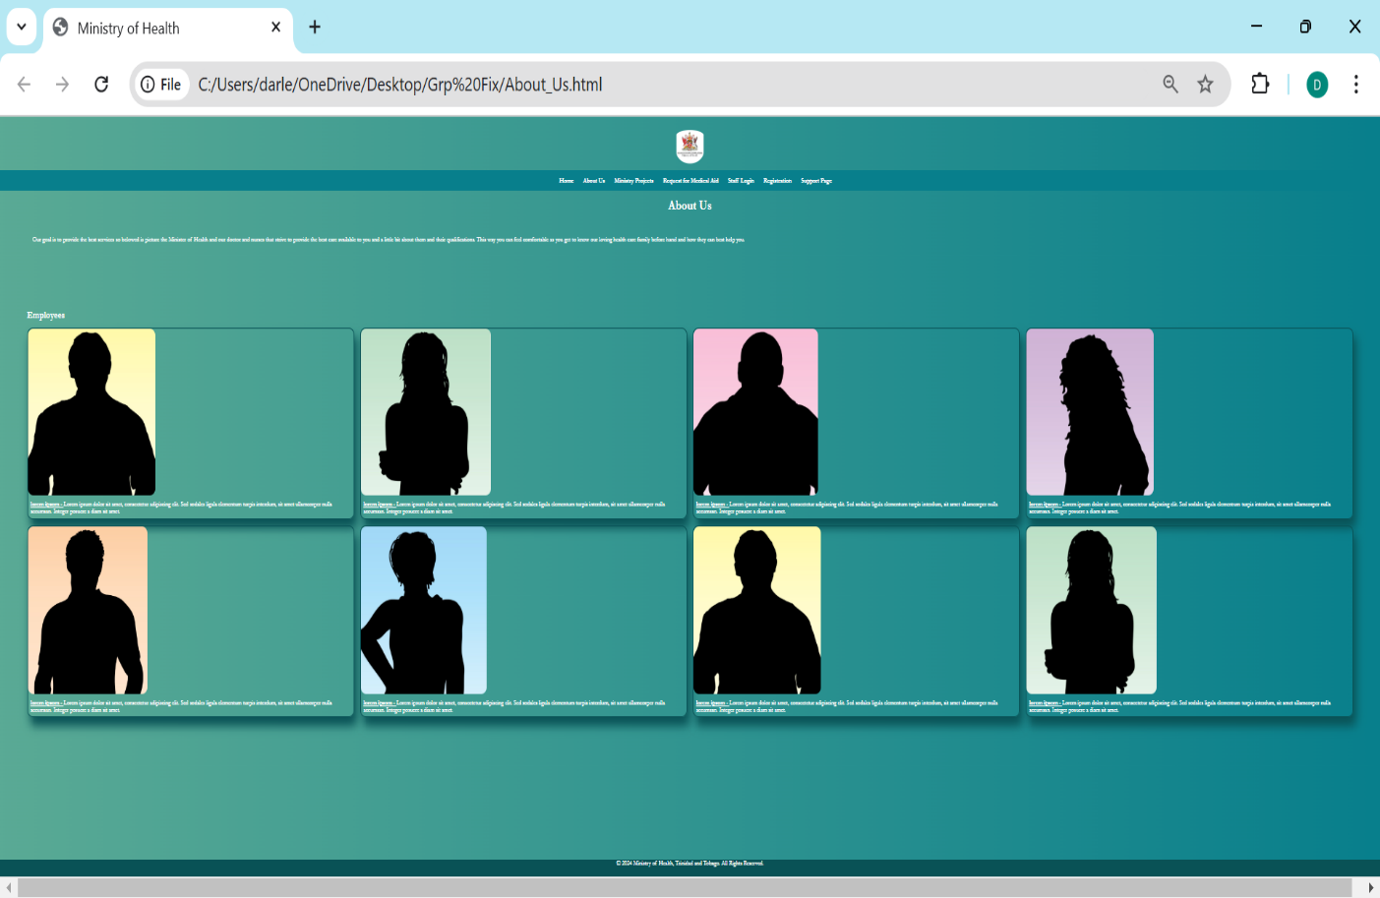

About Us Page Description

The about us page is easily accessible from the navigation bar with its clickable link showing the employees of the Ministry. It body consists of font family Times New Roman and a background color #087F8C. The text on the about us page is set to have a margin of 20px and text in the colour white it contains the text of Lorem ipsum. Here the grid element was employed to add the employees and the job descriptions there is a 20px gap between the elements. A border is added with a radius of 20px as well and a box shadow of 10px, 25px and 30px. The image has a max set height of 500px and width set at auto.

*Sign Up Page Functionality*

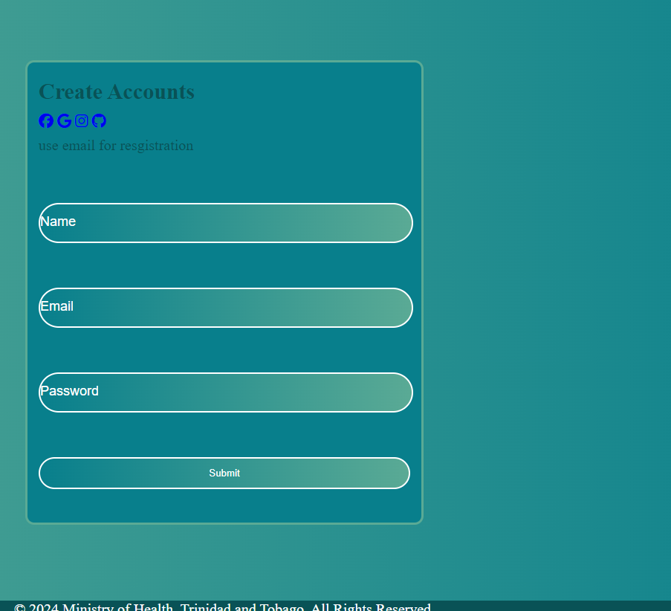

Sign Up page Description

Sign In Page Functionality

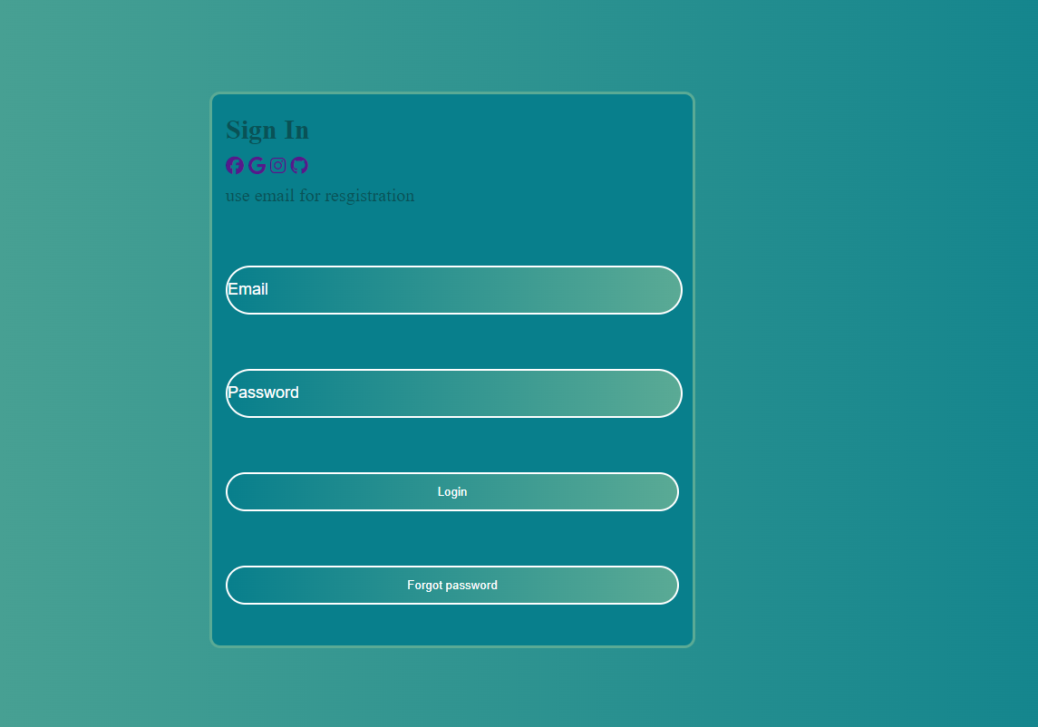

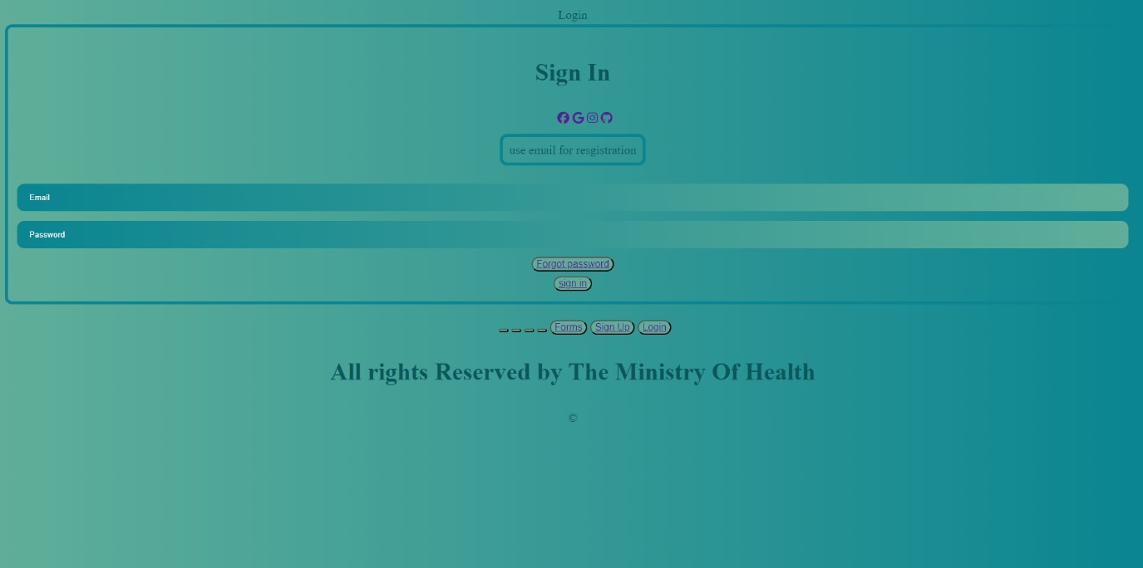

Sign in Page Description

Forms Page Functionality

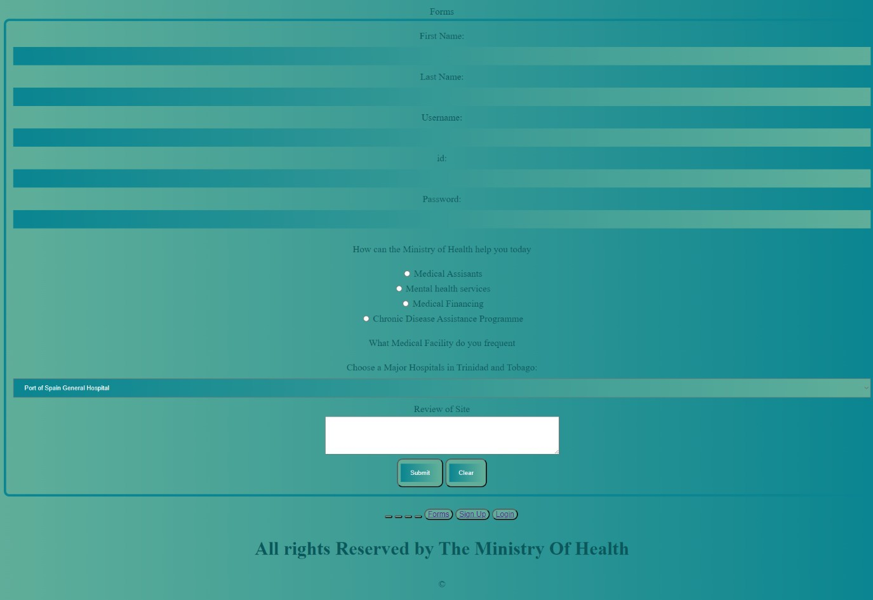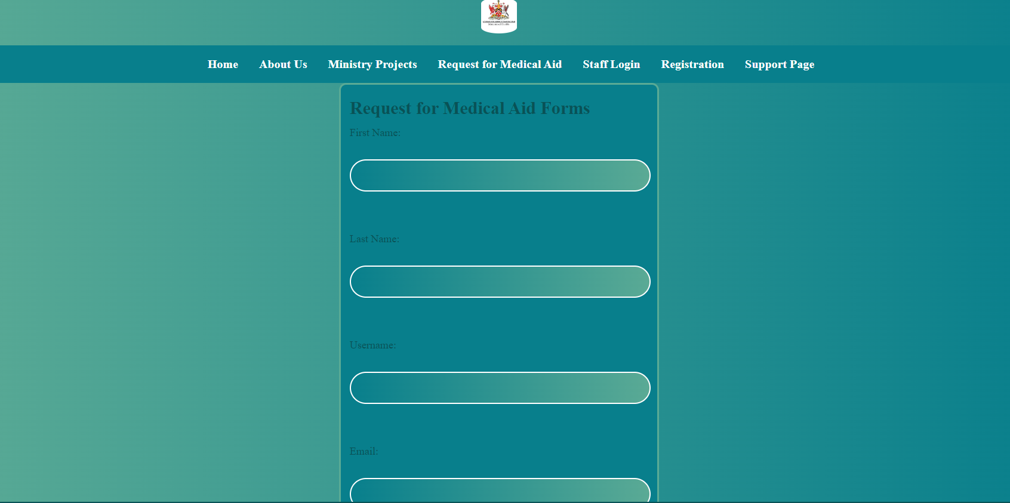

Forms Page Description

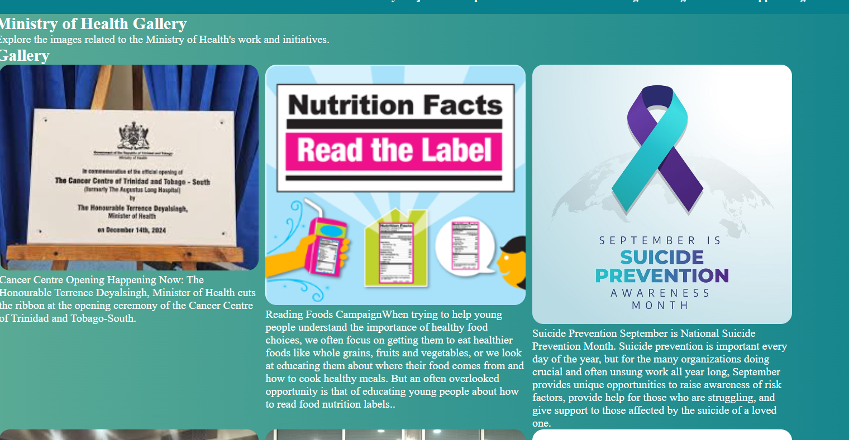Gallery

Support page

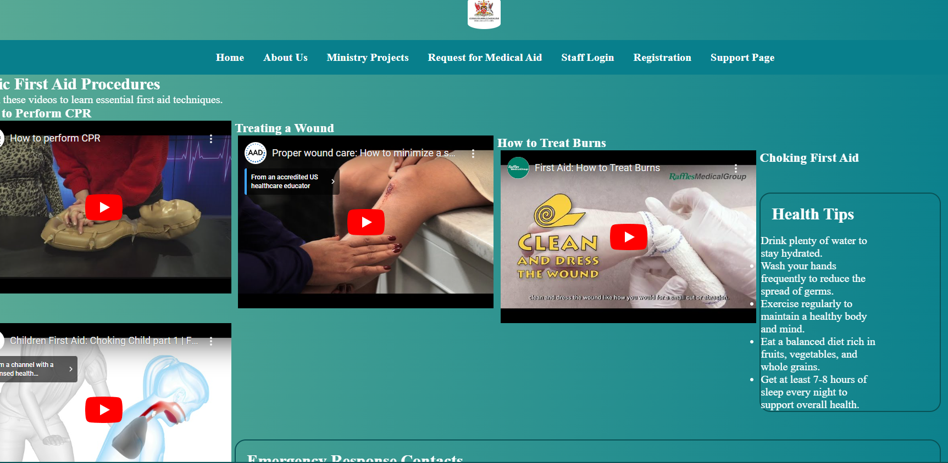

# Appendix 1- W3C Validation

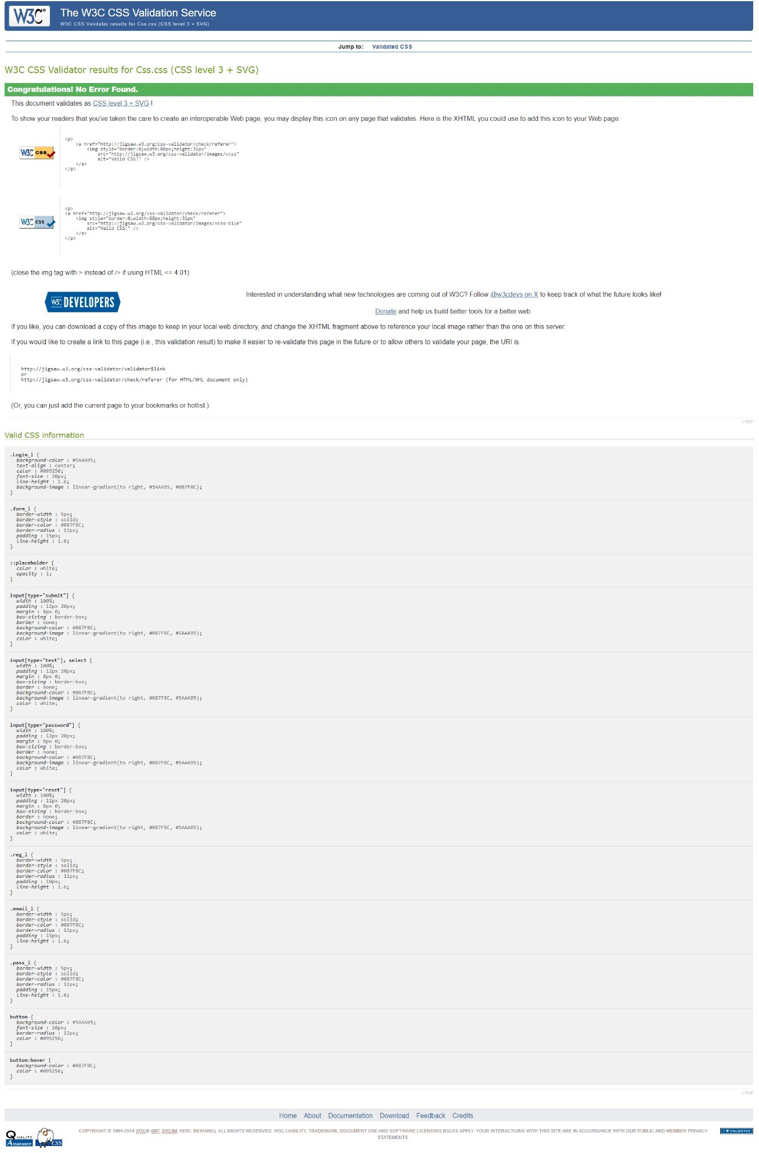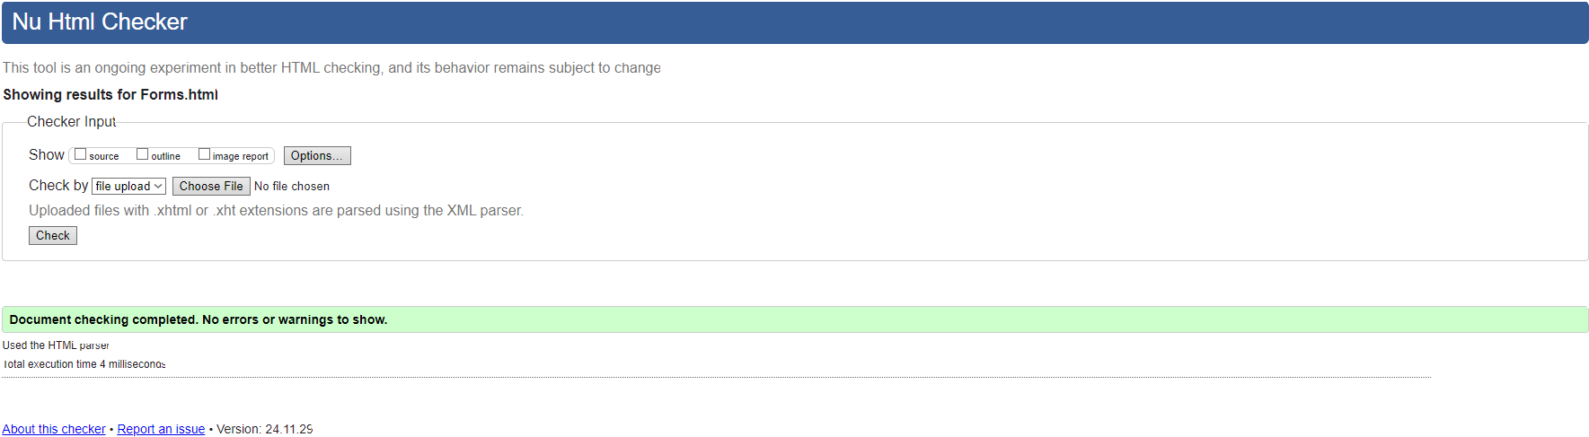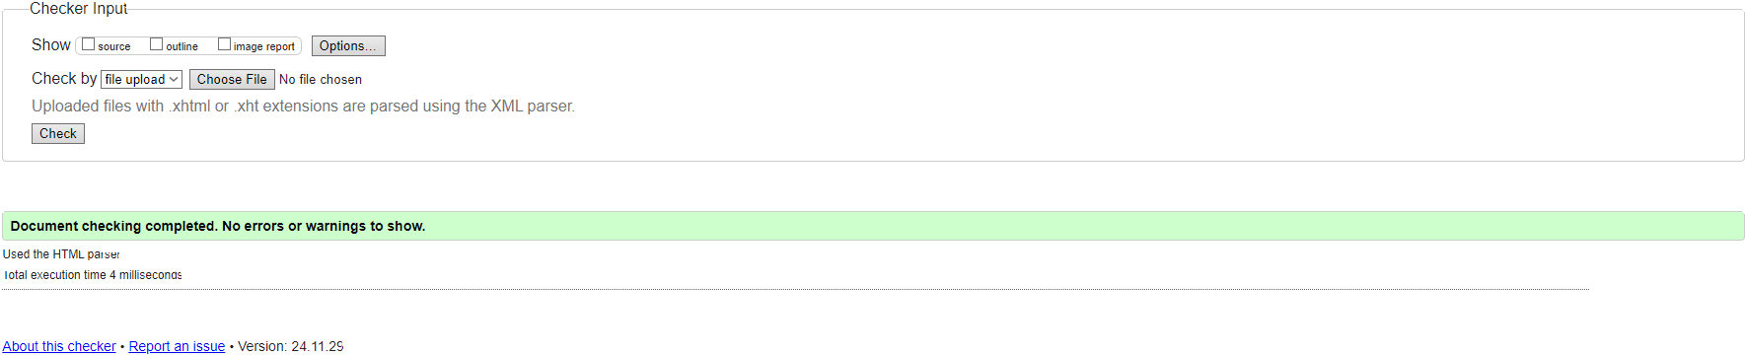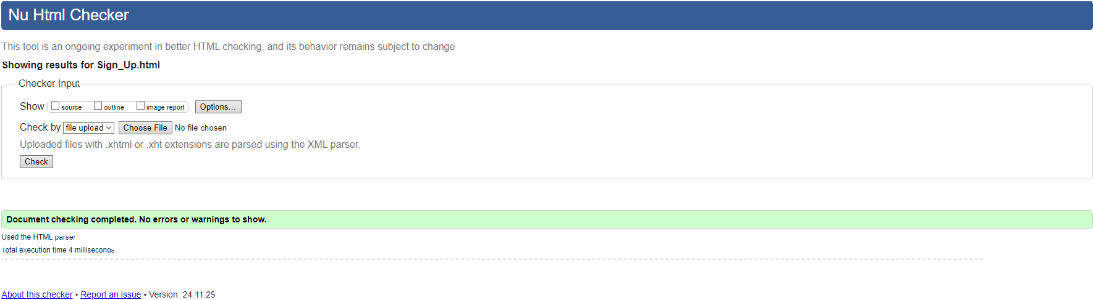

Index Page Validation

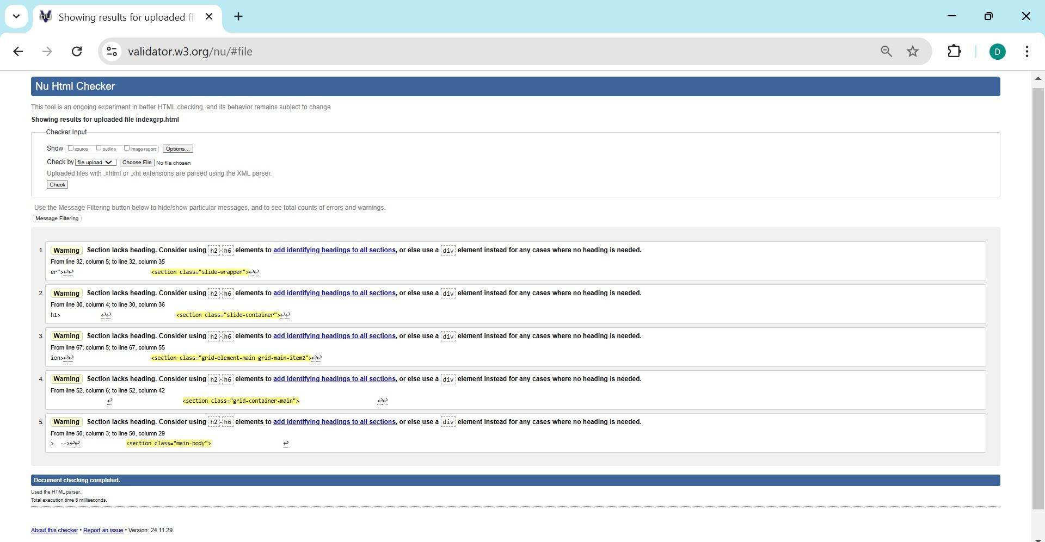About us Page Validation

CSS Validation

Gallery

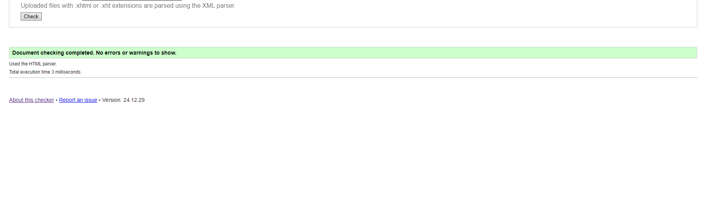

Support PAGE

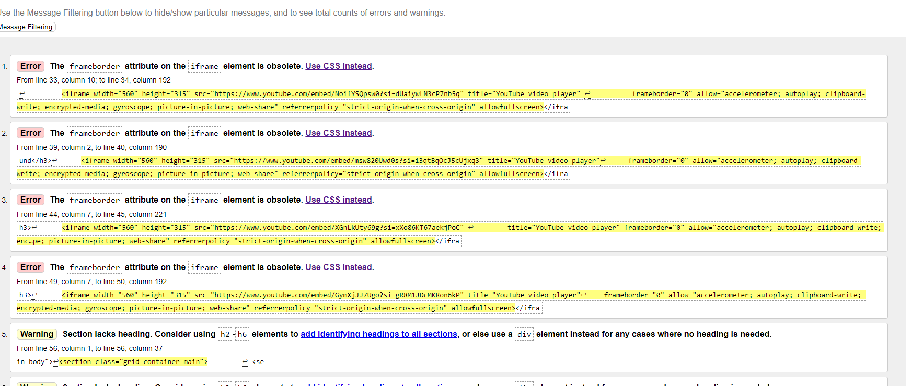

# Appendix 2

## Work and Meeting Schedules

|  |  |  |  |  |
| --- | --- | --- | --- | --- |
| Student Name | Activity/Exercis  e | Date | Time | Duration |
| Leon Barratt | Plan and design drawing  Page Creation Error Checking |  |  | 30 mins  3hrs 2hrs |
|  |  |  |  |  |
| Darlene Daniel | Wrote HTML and made adjustments to the home page  and about us pages | 29/11/2024 | 7:00pm-12:00pm | 4hrs |
| Darlene Daniel | Add HTML for | 4/12/2024 | 12:30pm-1:30pm | 1hr |

|  |  |  |  |  |
| --- | --- | --- | --- | --- |
|  | Index and Navigation Pages Added Navigation Page |  | 6:30pm-7:00pm | 30 min |
| Darlene Daniel | Edited CSS page  Sourced Images | 5/12/2024 | 10:00pm-1:00pm | 3hrs |
| Darlene Daniel | Validated Pages | 6/12/2024 | 8:00pm-8:30pm | 30min |
| Darlene Daniel | Added paragraphs to about us page, research how to insert images in a grid | 13/12/2024 | 9:00pm- 12:42am | 3 ½ hrs |
| Darlene Daniel | Continued to research and tweak slideshow  for index page | 14/12/2024 | 9:30am- 10:15am  2:40pm -3:40pm | 45min  1hr |
|  |  |  |  |  |
|  |  |  |  |  |
|  |  |  |  |  |

# Activity:

Plan and design drawing around 30 mins Page Creation Leon Barratt time taken 3 hrs Meeting on 28/11/2024 30 mins

Error Checking Leon Barratt time taken 2 hrs

## Meeting Schedule

|  |  |  |  |
| --- | --- | --- | --- |
| Meeting Date | Meeting Attendance | Meeting Agenda/Goals | Meeting  Duration |
| Nov 15th 2024 | Leon Barratt  Jonathan Wickham Darlene Daniel | Choose Ministry to design Assigned sample Layout | 20 min. |
| Nov 16th 2024 | Leon Barratt Jonathan Wickham  Darlene Daniel | Creation of Good Doc to input work | 5 min. |
| 19th Nov 2024 | Leon Barratt Jonathan Wickham  Darlene Daniel | Selected Webpage Palette Webpages Assigned | 2hrs |

|  |  |  |  |
| --- | --- | --- | --- |
| 28th Nov 2024 | Leon Barratt Jonathan Wickham Darlene Daniel |  | 30 min |
| 2nd Dec | Leon Barratt Jonathan Wickham  Darlene Daniel | Discussion of elements to add map etc Validation of Sign up pages etc | 1hr |
| 4th Dec 2024 | Leon Barratt Jonathan Wickham Darlene Daniel | Adding Pallet to pages Fixing errors | 2hrs |
| 6th Dec 2024 | Leon Barratt Jonathan Wickham  Darlene Daniel | Afixing Navbar to all pages ,  Fixing support pages, testimonial pages, buttons, login in and sign up pages | 1hr 30mins |

# Appendix 3- Citation

Leon Barratt:

[Icons login and sign up](https://fontawesome.com/) [Animated login and sign up](https://www.youtube.com/watch?v=g-xXunkbF6k) [Drop Down List](https://www.w3schools.com/tags/tag_select.asp)

[Buttons](https://www.w3schools.com/css/css3_buttons.asp) [Gradients](https://www.w3schools.com/css/css3_gradients.asp) [Forms](https://www.w3schools.com/css/css_form.asp)

**Gallery**

[**https://www.w3schools.com/css/css3_images.asp**](https://www.w3schools.com/css/css3_images.asp)

mg1

[https://www.google.com/url?sa=i&url=https%3A%2F%2Fwww.facebook.com%2FMinistryofHealthTT%2Fposts%2Fhappening-now-the-honourable-terrence-deyalsingh-minister-of-health-cuts-the-rib%2F998361195661077%2F&psig=AOvVaw1ogqvCdFjG3Zti6-WCAET0&ust=1734723598511000&source=images&cd=vfe&opi=89978449&ved=0CBUQjRxqFwoTCOijnpHLtIoDFQAAAAAdAAAAABAr](https://www.facebook.com/MinistryofHealthTT/posts/happening-now-the-honourable-terrence-deyalsingh-minister-of-health-cuts-the-rib/998361195661077/)

img2

[https://www.google.com/url?sa=i&url=https%3A%2F%2Fthrivingschools.kaiserpermanente.org%2Fread-the-label-campaign-helps-kids-understand-nutrition-impacts-of-eating%2F&psig=AOvVaw2iL_H6vXQKn0StpCFKF2-5&ust=1734723721718000&source=images&cd=vfe&opi=89978449&ved=0CBQQjRxqFwoTCNiBhczLtIoDFQAAAAAdAAAAABAw](https://thrivingschools.kaiserpermanente.org/read-the-label-campaign-helps-kids-understand-nutrition-impacts-of-eating/)

Img3

[https://www.google.com/url?sa=i&url=https%3A%2F%2Fhr.uw.edu%2Fcfd%2F2024%2F08%2F29%2Fsuicide-prevention%2F&psig=AOvVaw2bCdR_jDmRXiwEj-_YLaRi&ust=1734723838149000&source=images&cd=vfe&opi=89978449&ved=0CBQQjRxqFwoTCNiT3YDMtIoDFQAAAAAdAAAAABAE](https://hr.uw.edu/cfd/2024/08/29/suicide-prevention/)

Img4

[https://www.google.com/url?sa=i&url=https%3A%2F%2Fwww.paho.org%2Fen%2Fnews%2F4-9-2024-digital-health-revolution-trinidad-and-tobago-receives-cutting-edge-health-service&psig=AOvVaw0i5EvWfPx5jj5d8FNgSean&ust=1734723971373000&source=images&cd=vfe&opi=89978449&ved=0CBQQjRxqFwoTCKDT-sDMtIoDFQAAAAAdAAAAABAJ](https://www.paho.org/en/news/4-9-2024-digital-health-revolution-trinidad-and-tobago-receives-cutting-edge-health-service)

Img5

[https://www.google.com/url?sa=i&url=https%3A%2F%2Ftt.loopnews.com%2Fcontent%2Ffree-child-and-youth-mental-health-resources-launched&psig=AOvVaw30ZusIIpdxjsfhKpJkWqPf&ust=1734724127479000&source=images&cd=vfe&opi=89978449&ved=0CBQQjRxqFwoTCLjG6IzNtIoDFQAAAAAdAAAAABA6](https://tt.loopnews.com/content/free-child-and-youth-mental-health-resources-launched)

Img6

[https://www.google.com/url?sa=i&url=https%3A%2F%2Fwww.hsidn.org%2Fcommunity-health-calendar%2Fa8mr2tyl4j6wdll4x84pwn56ghyhbj-xcgyt-3xjgs-88yrk&psig=AOvVaw21EKFrzqaml3k3FDWRqpWj&ust=1734724284964000&source=images&cd=vfe&opi=89978449&ved=0CBQQjRxqFwoTCPD6mNvNtIoDFQAAAAAdAAAAABAE](https://www.hsidn.org/community-health-calendar/a8mr2tyl4j6wdll4x84pwn56ghyhbj-xcgyt-3xjgs-88yrk)

Img7

[https://www.google.com/url?sa=i&url=https%3A%2F%2Ftrha.co.tt%2Falpha%2Fblood-donation-drive%2F&psig=AOvVaw2BxYPdVpl1HJ0HhewPX9RE&ust=1734724373911000&source=images&cd=vfe&opi=89978449&ved=0CBQQjRxqFwoTCNDR1v_NtIoDFQAAAAAdAAAAABAS](https://trha.co.tt/alpha/blood-donation-drive/)

The url was disable

<https://health.gov.tt/services/blood-donation>

Img8

<https://www.instagram.com/minhealthtt/p/C5YpZX1LkHG/>

Img9

[https://www.google.com/url?sa=i&url=https%3A%2F%2Fbajajlifecare.com%2Fproduct%2Foxylife-resuscitation-kit-advance-plus-all-purpose%2F&psig=AOvVaw2rgAFLyPGcoQsY1SSYzHse&ust=1734724635152000&source=images&cd=vfe&opi=89978449&ved=0CBQQjRxqFwoTCKD8zfzOtIoDFQAAAAAdAAAAABAT](https://bajajlifecare.com/product/oxylife-resuscitation-kit-advance-plus-all-purpose/)

Img10

[https://www.google.com/url?sa=i&url=https%3A%2F%2Fwww.indianapca.org%2Fresource%2Fpress-release%2Fnational-lung-cancer-screening-day%2F&psig=AOvVaw32KZps9neU4pTzmPfqOxVj&ust=1734724709874000&source=images&cd=vfe&opi=89978449&ved=0CBQQjRxqFwoTCJCB0qnPtIoDFQAAAAAdAAAAABAE](https://www.indianapca.org/resource/press-release/national-lung-cancer-screening-day/)

Img11

[https://www.google.com/url?sa=i&url=https%3A%2F%2Fsciencephotogallery.com%2Ffeatured%2F6-flint-bottled-drinking-water-distribution-jim-west.html&psig=AOvVaw3ekP2RhJMi6vppCpYItjRp&ust=1734724814638000&source=images&cd=vfe&opi=89978449&ved=0CBQQjRxqFwoTCLj84NbPtIoDFQAAAAAdAAAAABAd](https://sciencephotogallery.com/featured/6-flint-bottled-drinking-water-distribution-jim-west.html)

Img12

[https://www.google.com/url?sa=i&url=https%3A%2F%2Fm.facebook.com%2FRDLGTT%2Fposts%2F1348221648679690&psig=AOvVaw0Aj6LV6D-CxSa0ymPDiMlw&ust=1734724965303000&source=images&cd=vfe&opi=89978449&ved=0CBQQjRxqFwoTCODgi5nQtIoDFQAAAAAdAAAAABAS](https://m.facebook.com/RDLGTT/posts/1348221648679690)

Img13

[**https://www.google.com/url?sa=i&url=https%3A%2F%2Fhealth.gov.tt%2Fservices%2Fwomens-health&psig=AOvVaw2WI2zvbfYyCcaTnTVGzBpo&ust=1734725138089000&source=images&cd=vfe&opi=89978449&ved=0CBQQjRxqFwoTCIj-8OvQtIoDFQAAAAAdAAAAABAn**](https://health.gov.tt/services/womens-health)

**Img14**

[**https://www.google.com/url?sa=i&url=https%3A%2F%2Fnewsday.co.tt%2F2024%2F08%2F04%2Ftrinidad-and-tobago-commemorates-world-breastfeeding-week%2F&psig=AOvVaw0QNSOugqPoVHeFGNUo301g&ust=1734725196733000&source=images&cd=vfe&opi=89978449&ved=0CBQQjRxqFwoTCNDupuTRtIoDFQAAAAAdAAAAABAH**](https://newsday.co.tt/2024/08/04/trinidad-and-tobago-commemorates-world-breastfeeding-week/)

**Img15**

[**https://www.google.com/url?sa=i&url=https%3A%2F%2Frenecassin.org%2Finternational-womens-day-statement-2024%2F&psig=AOvVaw2Dp-crj3Q6wkcvR-XMrl9f&ust=1734725313554000&source=images&cd=vfe&opi=89978449&ved=0CBQQjRxqFwoTCJi968LRtIoDFQAAAAAdAAAAABAI**](https://renecassin.org/international-womens-day-statement-2024/)

**Img16**

[**https://www.google.com/url?sa=i&url=https%3A%2F%2Fwww.mpu.gov.tt%2Fover-5200-persons-vaccinated%2F&psig=AOvVaw3WNgt7LjsF9t3TaQSkRo7V&ust=1734725431952000&source=images&cd=vfe&opi=89978449&ved=0CBQQjRxqFwoTCNDFzvfRtIoDFQAAAAAdAAAAABA6**](https://www.mpu.gov.tt/over-5200-persons-vaccinated/)

References

Balielo Jr., V. (2020, March 25). [Baby with ink on foot]. [www.pexels.com.](http://www.pexels.com/) <https://www.pexels.com/es-es/foto/bebe-con-tinta-a-pie-4005611/>

Blueterminal. (2022, August 28). *Image Gallery in HTML/CSS* [Video]. YouTube. <https://www.youtube.com/shorts/FP7qQR9sqcE>

Cotonbro studio. (2020, October 28). [A Person Getting His Hand Bandaged]. [www.pexels.com.](http://www.pexels.com/) <https://www.pexels.com/photo/a-person-getting-his-hand-bandaged-5721552/>

Evening_tao. (n.d.). [Modern Business Center]. [www.freepik.com.](http://www.freepik.com/) [https://www.freepik.com/free-](https://www.freepik.com/free-photo/building_1242893.htm)

[photo/building_1242893.htm](https://www.freepik.com/free-photo/building_1242893.htm)

Government of the Republic of Trinidad and Tobago Ministry of Health. (n.d.). *About us*. Ministry of Health. <https://health.gov.tt/about-us>

Kjpargeter. (n.d.). [Avatar silhouettes]. [www.freepik.com.](http://www.freepik.com/) https://[www.freepik.com/free-](http://www.freepik.com/free-)

vector/avatar-

silhouettes_12782565.htm#fromView=search&page=1&position=4&uuid=b683a679-f100-

4dab-8122-ceb50de3f375

Mart Production. (2021, March 9). [Man in MRI]. [www.pexels.com.](http://www.pexels.com/) <https://www.pexels.com/photo/gente-hombres-tecnologia-habitacion-7088829/>

Miroshnichenko, T. (2020, December 19). [Black and white photo woman adjusting x-ray machine]. [www.pexels.com.](http://www.pexels.com/) [https://www.pexels.com/photo/blanco-y-negro-mujer-tecnologia-clinica-](https://www.pexels.com/photo/blanco-y-negro-mujer-tecnologia-clinica-6234982/)

[6234982/](https://www.pexels.com/photo/blanco-y-negro-mujer-tecnologia-clinica-6234982/)

Shvets, A. (n.d.). [Photo woman having a dental check up]. [www.pexels.com.](http://www.pexels.com/) <https://www.pexels.com/photo/woman-having-a-dental-check-up-3845625/>

W3Schools. (n.d.). *HTML images*. W3Schools Online Web Tutorials. <https://www.w3schools.com/html/html_images.asp>